Le Minh Quang 21089141

storage:

dbPath: T:\mongodb\db\node1

journal:

enabled: true

systemLog:

destination: file

logAppend: true

path: T:\mongodb\db\node1\mongod.log

net:

port: 27011

bindIp: 127.0.0.1

security:

authorization: enabled

keyFile: C:\Users\Student\Downloads\data bai tap tuan 09\pki\m-keyfile

replication:

replSetName: rep-example

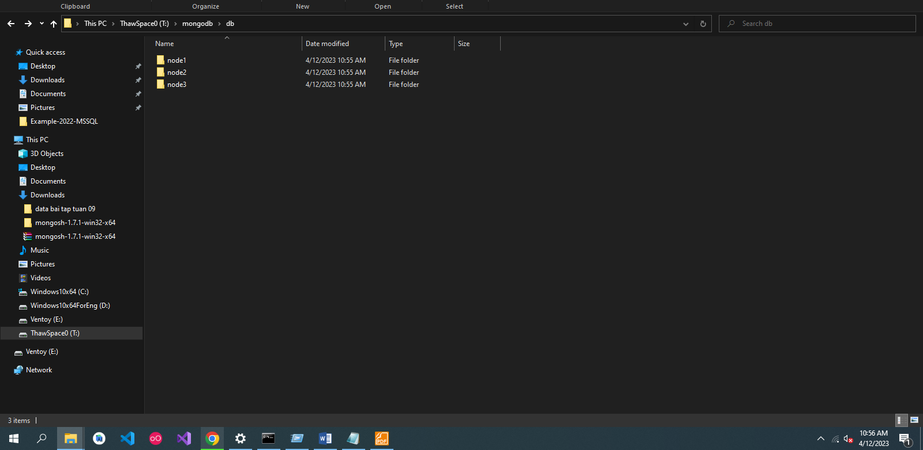

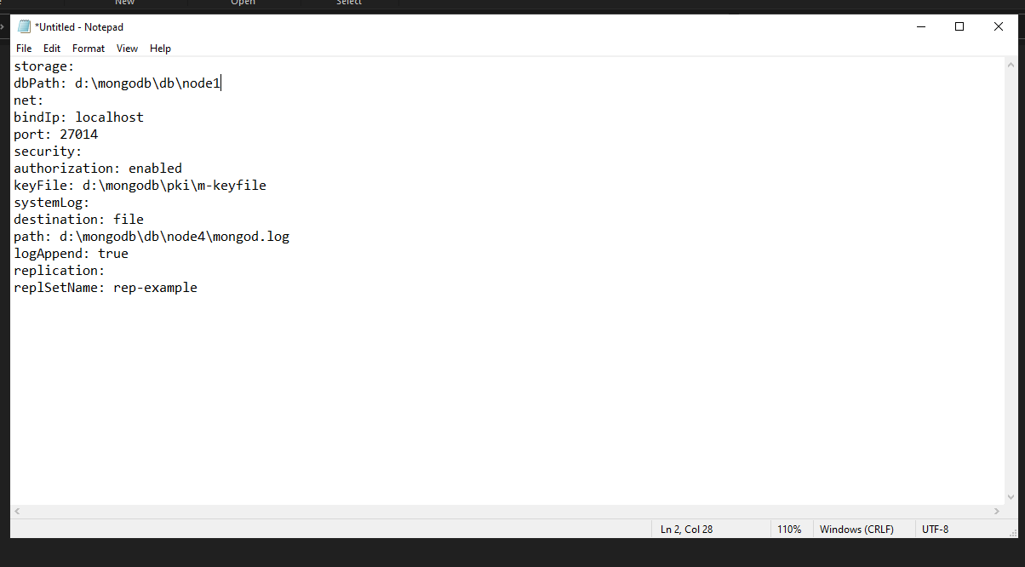

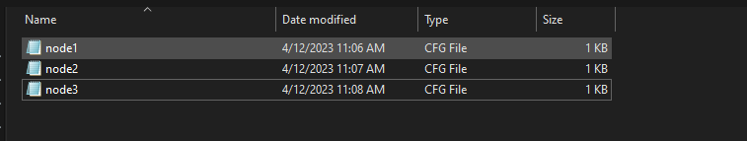

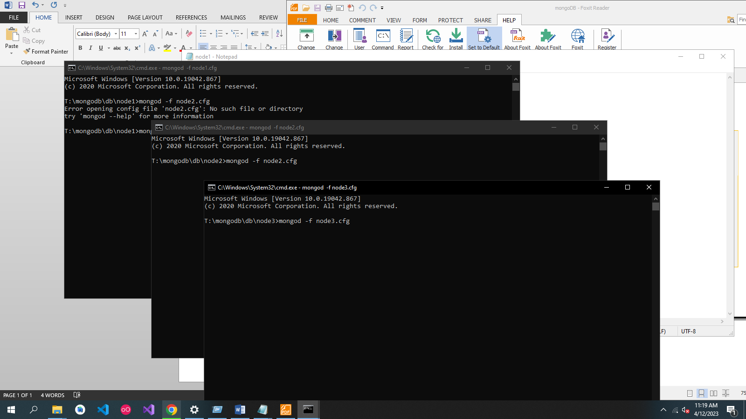

mongosh --host 127.0.0.1:27011

rs.initiate()

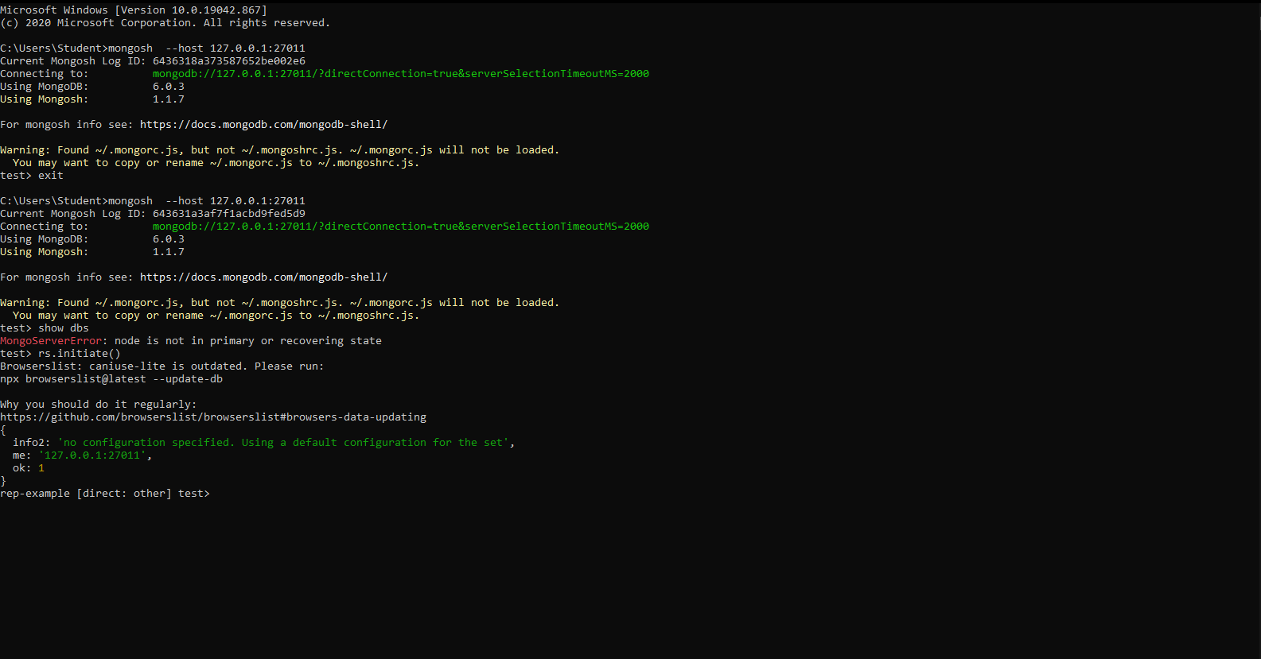

Use admin

db.createUser({user:'m-admin',pwd:'m-pass',roles:[{role:'root',db:'admin'}]})

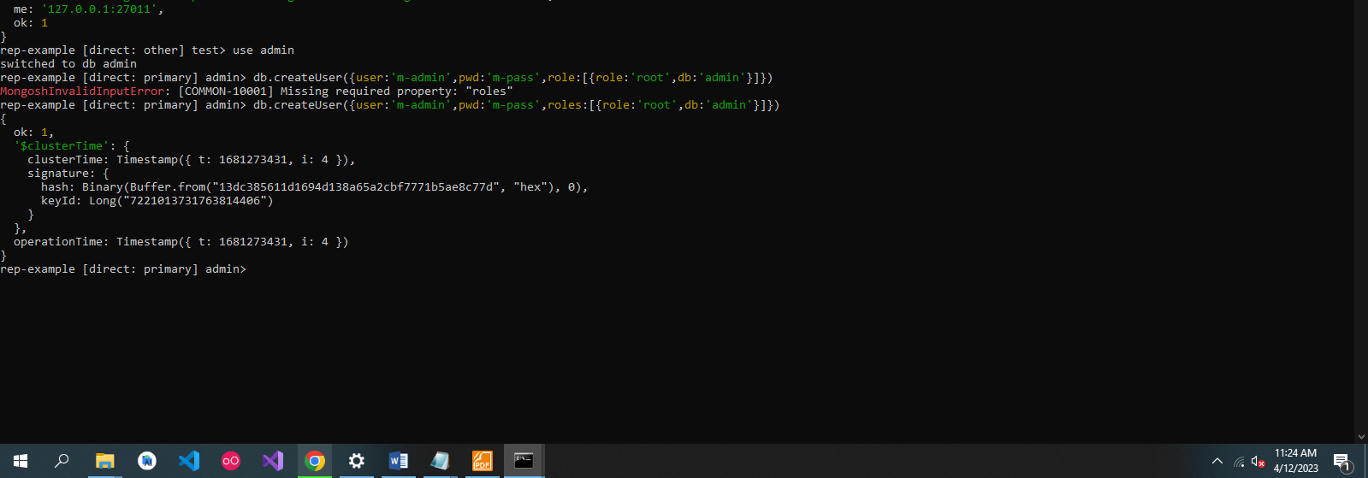

mongosh --host rep-example/localhost:27011 -u m-admin -p m-pass --authenticationDatabase admin

